high level design document

This high-level design document has been created to outline the proposed system design for new Atlantica Reservation and Management Tool (ARMT). The ARMT is intended to replace the legacy reservation and maintenance system currently used by Atlantica Hotel. By designing, testing, and deploying the ARMT, hotel will improve its capabilities in maintenance management, tracking customer booking, and reporting bills to owner. This document and the technical specifications listed herein comply with all Atlantica Hotel technical standards and infrastructure.

# INTRODUCTION

## Purpose and Scope

The purpose of this high-level design documentis to provide a description for how the new ARMT will be constructed. The high-level design document was created to ensure that the ARMT design meets the requirements specified in the project requirements documentation as well as the improvements to existing maintenance management practices and tools. The high-level design document provides a description of the system architecture, software, hardware, database design, and security.

## Project Executive Summary

From the Hotel Owner’s point of view, they need to be ahead of other contemporaries in order to be profitable and established. Hence, with the technologies booming across the world, the management wants to use it and give more accessibility to customers and mint some money from third party advertisements and payment providers.

### System Overview

Atlantica hotel has faced some challenges and shortcomings in managing hotel maintenance metrics, tracking staffs, and giving good accessibility and deals to customers. The proposed management website will utilize existing ARMT and hardware to provide an advanced version which will standardize and improve the efficiency of Atlantica’s maintenance management capabilities.

The ARMT is designed as an enterprise software application which is compatible with and leverages existing hardware and infrastructure. Additionally, the advanced system is compliant with all internal Atlantica Hotel’s network security protocols and policies as well as hotel regulatory policies.

The ARMT is also compatible with existing software suites to include Webapp and MySql, as well as excel. The tool will provide various user interfaces which will allow data entry, updates, tracking, and report generation. It will also allow users to export data to various existing software tool like MS Excel for various uses.

One of the primary benefits of the tool over the legacy system is its ability to consolidate all maintenance data and generate real-time reports and analysis of fleet status, customer feedbacks, chronic maintenance problems, and various other metrics like A/B testing. Until now Atlantica Corp. has relied upon legacy software with various reporting and data constraints and limited user interfaces which has resulted in poor reporting, tracking, and management as well as a general lack of attraction among the customers.

The ARMT will provide the following capabilities:

* Pre-designed reporting at various time intervals as well as manually generated reports
* Integration of all staff’s data which allows for real-time report generation and simplifies management of all staff activities
* Enhanced and additional user interfaces which provide customers with much simpler reservation, update/cancel booking, airport pickups, and other capabilities
* Good payment gateway provider to increase customers payment through online portal

### 1.2.2 Design Constraints

#### 1.2.2.1 Time Constraints

Like ever project this project is also affected by the time constraints, as design and implementation parts which has multiple features like portal for customer and hotel owner should be completed within four weeks as to meet-up with other hotel competitors. So, to achieve this every team member should strictly follow the specified time schedule.

1.2.2.2 General Constraints

The Distributed Network Traffic Controller must be user friendly and as automated as possible. Administrators should not be required to do anything besides the initial setup, and users should not be required to know any of the workings. Without logging in, the user will only have the ability to view that IP’s current average and history. After logging in, that user then has the ability to change settings and user histories.

#### 1.2.2.3 Performance Constraints

The website performance depends up on different factors like responsiveness (real-time responsiveness is required for bill payment), attractive user interface with proper placement of the advertisements which should follow the certain standard, so that user won’t get distracted and won’t get bored. By following the UI standard, the user won’t have problem in navigating through the website for the specific thing they are looking for. There are other factors which will impact this project are like security requirements, management of the websites.

1.2.2.4 Financial Constraints

The project is financially supported by the payment provider by giving their gateway access. So, as the user of the website increases there would be requirement of more memory and networks which is going to cost extra resources of the hotel.

## Points of Contact

The following table defines the ARMT System Design roles and responsibilities. This matrix also serves as the list of points of contact for issues and concerns relating to the ARMT System Design.

|  |  |  |  |
| --- | --- | --- | --- |
| NAME | ROLE | PHONE | EMAIL |
| Bharat | Project Manager | 909-909-9898 | bharat@Atlantica.ca |
| Nawaz | Scrum Master | 909-909-3434 | nawaz@Atlantica.ca |
| Kannappan | Lead Designer- UI | 909-909-9892 | kanna@Atlantica.ca |
| Sarbottam | Lead Designer- Architecture | 909-909-9293 | sar@Atlantica.ca |
| Ashwin | Quality Assurance Specialist | 909-909-9294 | ashwin@Atlantica.ca |

## Glossary

ARMT – Atlantica Reservation and Management Tool

# SYSTEM ARCHITECTURE

## System Hardware Architecture

The ARMT design is based on existing hardware architecture already deployed across the Atlantica enterprise. This hardware consists of the following components:

* Work Stations
* Switch
* Servers
* Hard drives
* Routers

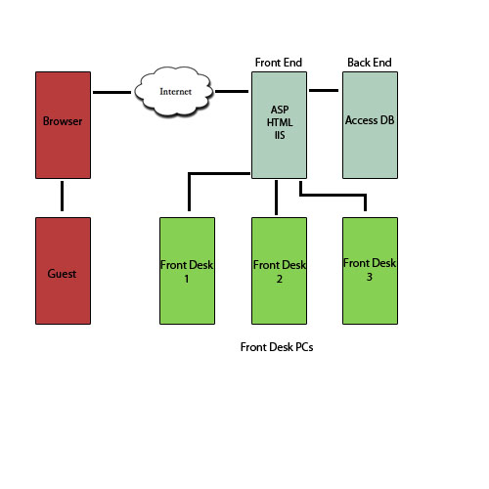

## System Software Architecture

1. The project will have a relational database backend that is SQL based. The actual software used is PostgreSQL.

2. Interfacing with the database to display information on the user’s web browser will be done using JSP. It can connect to the database and parse it into viewable HTML code.

3. Tomcat compiles JSP pages into servlets to be displayed through Apache..

4. Apache - An open source web server that will display requested pages. HIGH LEVEL DESIGN Revision: 1.0 Version Date: 2/2/2005 5

5. Automated interfacing with the database behind the scenes will be JDBC.

6. DHCP assigns IP addresses.

7. After a Kernel recompile, IPTables allows for IPMasquerading. IPTables also acts as a built in firewall.

# FILE AND DATABASE DESIGN

## Database Management System Files

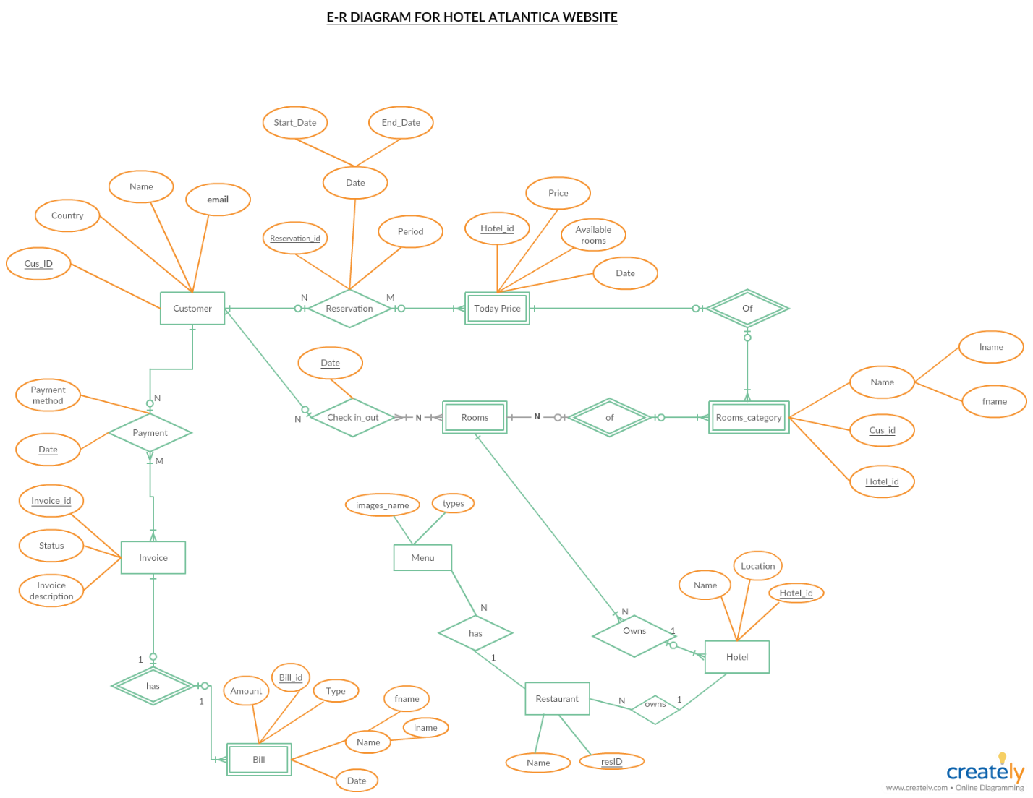

1. Customer Table:

* Cus_Id
* Name
* Country
* Email

1. Hotel

* Name
* Location
* Hotel_Id

1. Bill

* Bill_Id
* Name
* Amount
* Type
* Date

1. Reservation

* Reservation_Id
* Date
* Period

1. Payment

* Date
* Payment Method

1. Restaurant

* resId
* Name

1. Menu

* Type
* image_name

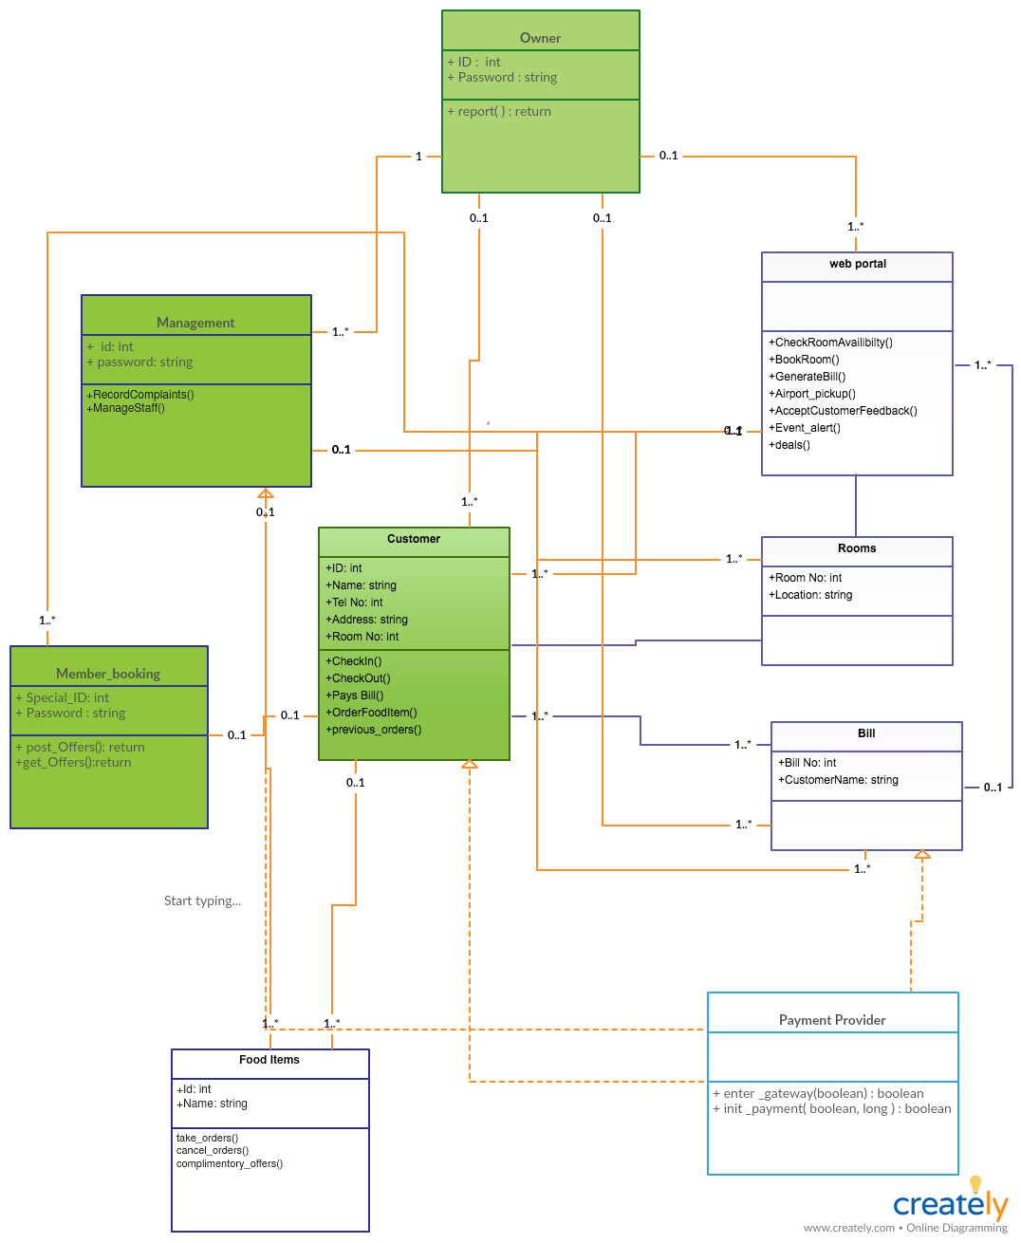Class Diagram with function modules.

## Non-Database Management System Files

With today’s emerging technological world there is Non-Database Management System files consists of the information of different types like structured, semi-structured, unstructured and polymorphic data which are not stored in the database of the websites. This information which cannot incorporate with the table/key model of the relational database. So, this information are stored as non-database files. The following are the list of the files which website stores in the non-database management system:

* The policies plan of the hotel which defines different conditional related to the hotel like terms and condition of reservation, bookings, discount in meals and rooms, age restriction for hotel check-in/check-out, prohibited items, payment policies and general policies.
* The information related to payment gateway are also stored in the non-database management system.

# HUMAN-MACHINE INTERFACE

## Displays

